**Web Design**

**Project Report**

|  |  |
| --- | --- |
| **Project Team** | |
| **Student No.** | **Student Name** |
| 15513377 | Kevin Reid |

**Travel Agent Website Project**

1. **Overview / Introduction**

**Motivation for the Project**

I have been asked to create a website for the travel agent company, TourHelper. They are a company which provides their customers with information about their company and showcases their products and services.

I have been given the instruction to create and design a logo for TourHelper. Seeing as the subject matter of this website is travel related, I’ve no problems of thinking of ideas for a logo. Some that I do have in mind is of a smiling sun giving the thumbs up sign. I think this would symbolize the name of the company, TourHelper with the logo perfectly. In Adobe Photoshop, I did a design mock up of what the logo could look like. It is a rough design and I wish to improve upon it.



My objectives for this website is make it easy for people to use, up to date for the modern standards of websites and to make it so it draws attention to potential new customers.

**Research**

For this project I researched a number of travel websites which I deem influential to the design of the travel agent website:

* Budget Travel
* Cassidy Travel
* TripAdvisor
* eBookers
* Expedia

Budget Travel is one of Ireland’s leading travel agents. In recent years, they scaled down their business and are solely are a web based travel agents. Budget Travel specialize in all inclusive package deals to worldwide destinations. While their mobile version of their website looked quite well I dislike the desktop version of their website. It feels cluttered and difficult to navigate through.

Cassidy Travel is another one of Ireland’s leading travel agents. Although they still operate physical travel shops throughout Ireland, they do manage a travel website which assists potential customers to use them as their travel agent. Cassidy Travel’s website suffers the problems that Budget Travel’s website has. It’s content is heavily restricted and not at spaced out to make easier for the user to read.

TripAdvisor is the world’s largest travel website. Their mission is to enable travellers to and book their perfect trip through them. TripAdvisor checks hundreds of websites to find great deals. They also offer reviews on thousands of destinations. Their website is engaging and easy to use but it does have one bit of a downside. Upon entering their website you are met with a pop-ad asking you to take their survey. This could put off some potential customers from using the website.

eBookers is Ireland’s longest established online travel agency. They offer some of the best worldwide travel deals. The travel agency offers a full range of travel products online. Both their mobile site and desktop site is lacking content. The layout of their website is not conventional to today’s standards, while the website itself is not appealing to users.

Expedia is one of the very first travel agents set up the World Wide Web. Launched by Microsoft in 1996, their objective is to give the customer the option to pick and choose how they want to travel. Expedia manages to create a website which is both simple and easy to navigate through. Their website is both perfectly displayed on a desktop and smartphone.

Having looked at just some of the competitors, I have a better understanding on how to approach on design this travel agent website for my client. I’ve come up with a number of ideas for the website project that I will try and to incorporate. Some ideas include: showing the latest deals on the homepage which will attract the users straight away, putting social medias link buttons which will give the user access to the latest deals on their Facebook and Twitter.

**Technical Approach**

My client has outlined the specific requirements for the website. The client wishes to give the website an orange background. The color scheme of the website will consist of orange, white and blue. These colors will be incorporated into the logo of the website which will be placed in the top right hand corner. The main body of content for the travel website will be viewed on the right hand side of the page. All content of the website will be view on that side of the webpage. While the left hand side navigation will consist of advertisements for deals and social media links. A map feature will outline the destinations that the travel agency can fly to.

1. **Wireframe**

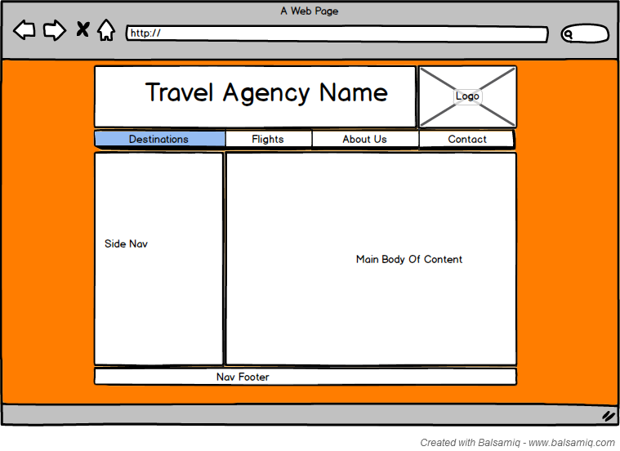

Once my client had outlined the requirements for what the website should have, I designed a basic wireframe for it. First off, I set the background for the website as orange as directed by my client. I found this part to be tricky as there are many different shades of orange you could go for. Originally, I went for a lighter shade of orange but after much consideration I found it to be too light because the shade of orange you would find on a slice of cheese. I decided to go a bit a darker, more on the neon side of orange. I drew my inspiration for choosing this colour after watching the film The Fast & The Furious, which has a car that’s shares the same colour as the background of the website.

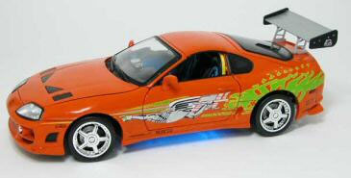

The logo for the website will situated at the top right hand corner of the website. Across the top of the website will have the name of the company so it will be very to all users what website they are visiting.

Below the name and logo, there will be a navigation bar which house the main links for the website. Some links will include Destinations, Flights, About Us and Contact. Although these are likely to change as more important links could be needed to be put into the navigation bar.

On the left hand side of the website, there will be space for a side navigation box. In this box there will be social media links and advertisements for the website and travel deals. Down the right hand side of the page there will be the main body of content for the website. All content of the website will be view on that side of the webpage. This box will have the majority of the website’s information.

I decided to include a navigation footer on the website. I will use this to put in additional links such as Terms & Conditions and other details retaining to this website.

1. **Production Log**

I first began to build a template for the website. In the template I included all of the requirements that my client ask for. It was at this stage when I decided to design the travel agent’s website logo. Going off my original logo design, I chose to drop the idea of a smiling sun with giving the thumbs up and to change the logo to just a hand giving the thumbs up. Through the use of Google Image Search, I found a licence free image of the thumbs up symbol. I chose this image because I thought it would work very well for the branding for this travel agent company.



My next decision was to decide on what font type should I use for the banner logo of the website. I thought a san-serif font type would work well with the design that I had in mind. I’m a fan of the clothing brand Superdry and I like the look of the font that they use on the products. So, I found out that the font type that they use is Coolvetica and it is also a font type that is free to use.



While designing the banner, I tried out a number of different ways to structure the name of the travel agent company, TourHelper. I settled on keeping the name all lower case and without a space between the name “TourHelper”. Keeping with the theme of having a lower case banner, I decided to make all headings tags of the website lower case.



The logo of the website looks very well and goes nice with background colour. This colour scheme of orange, black and white features heavily throughout the website. My whole reason to include a sidebar was to add social media features. For this website, I started a Facebook and a Twitter account for TourHelper. I was able to successfully embed TourHelper’s Twitter feed into the sidebar, but I was unable to incorporate a Facebook like button because Facebook’s social media plugins are more suitable to large sidebars than that’s currently displayed on the website. Below the main body of the webpage is the footer. In the footer is a smaller version of the logo and the copyright for the website.

**index.html**

The homepage features a cycling banner feature. I’ve always had in mind to incorporate a cycling banner in the website and thought this was the best place for it. I used the cycling banner as a way to show the latest offers that are available from TourHelper. Below the cycling banner on the homepage is a subscription box for customers to sign up so they get sent the latest offers from TourHelper to the email. This form validates for the correct email address structure. Once the email has been submitted, a confirmation box appears thanking the user for subscribing.

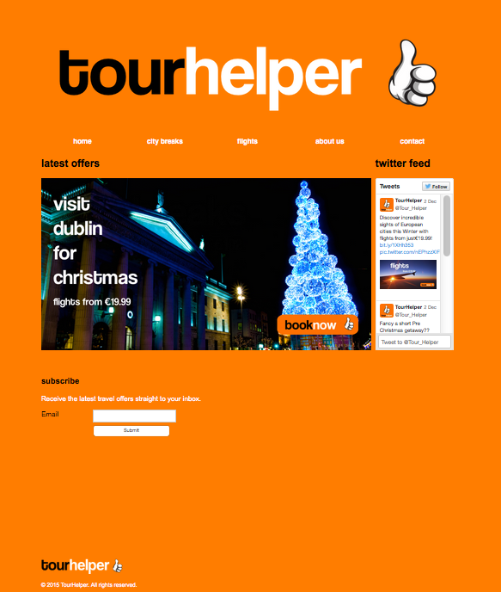

**city-breaks.html**

On this page is when the user can choose between 6 city destinations to visit. The options on this page are page city break deals. The options to choose from a some of the most popular city destinations in Europe. Choosing one of the options will bring you to the booking page for that destination. This package includes flights and accommodation. The images used for the cities chosen have all be taken from Google Image Search and have been approved by the copyright owners to being reused.

I originally wanted the text on the images to be responsive but I was unsatisfied with the results I was getting from this process and decided to just put the text in the images themselves.

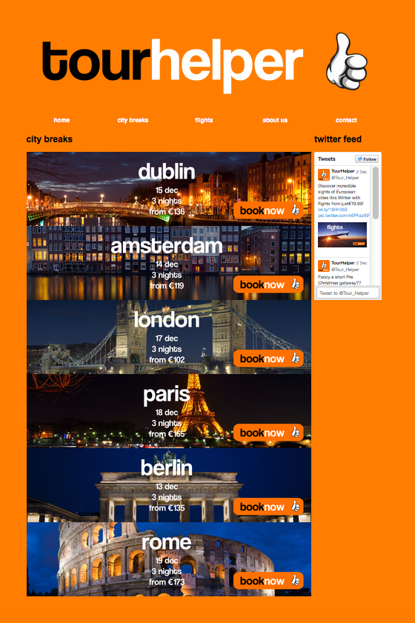

**flights.html**

On the flights page of the website is where the user can choose from the same 6 city destinations and just book a flight to that destination.

Again, I originally wanted the text on the images to be responsive but I was unsatisfied with the results I was getting from this process and decided to just put the text in the images themselves.

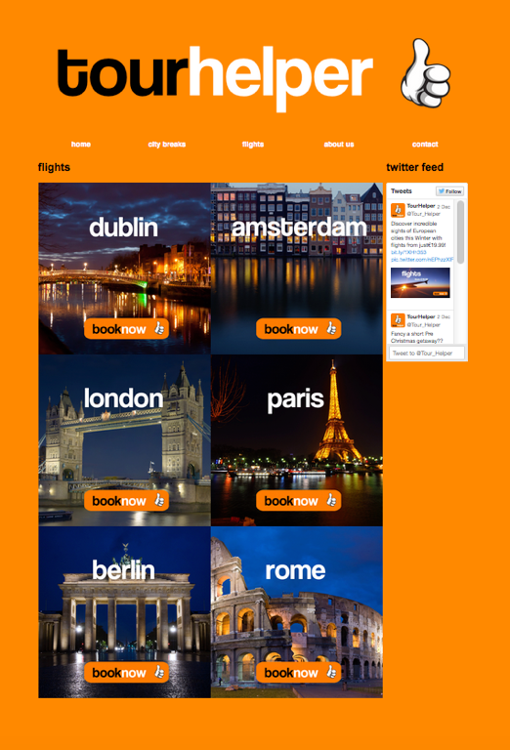

**dublin.html, amsterdam.html, london.html, paris.html, berlin.html, rome.html**

When the user chooses a city breaks package or a flights they brought to the booking page for that city. Whether the user chooses a city breaks package or a flight, they will notice that it brings them to a single booking page with option for city breaks and flights displayed on the same page. This is done by use of table of contents span tags. If the user chooses a city breaks package they will brought to the start of the image of the city breaks banner. If the user chooses a flight they will brought to the start of the image of the flights banner.

The booking details for the city breaks package include departing date, returning date, duration, hotel, number of rooms, number of guests, choice of airline and number of passengers. The input boxes for departing, returning and duration are disabled for the user as those options are already been made by the type of package. There is a choice of three hotels to choose from and choice of two airlines to fly with. These options are made by using the dropdown menu for them. The way the user can choose between how many guests, rooms and passengers they choose is done by using radio buttons. When the user is finished, they press the Submit booking button and they get prompted to complete the booking or cancel the booking. If the user chooses ok, below the form it will display “Booking Confirmed”. If the chooses cancel, below the form it will display “Booking Cancelled”.

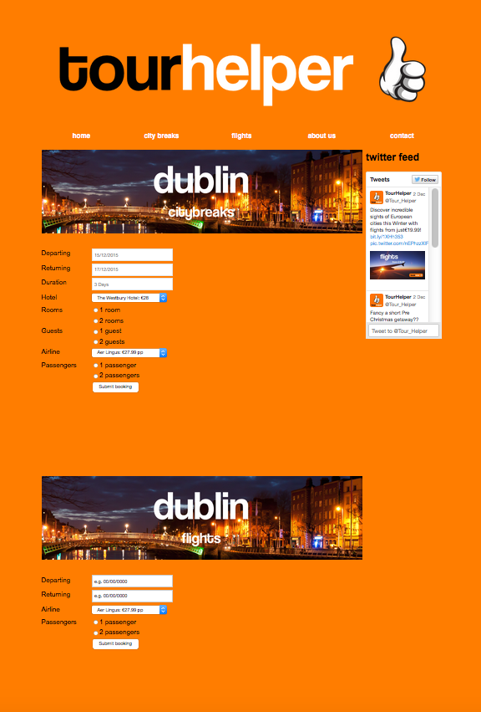

The booking details for the flights include departing date, returning date, choice of airline and number of passengers. The input boxes for departing and returning dates. I originally want to use a jQuery datepicker so the user could just choose from a dropdown calendar and pick which date they want. But I unable to get this feature working on the website. There is a choice of two airlines to fly with. This option is made by using the dropdown menu for it. The way the user can choose between how many passengers they choose is done by using radio buttons. When the user is finished, they press the Submit booking button and they get prompted to complete the booking or cancel the booking. If the user chooses ok, below the form it will display “Booking Confirmed”. If the chooses cancel, below the form it will display “Booking Cancelled”.

**about.html**

The about us page on the website contains a brief history and a bit of background of the company.

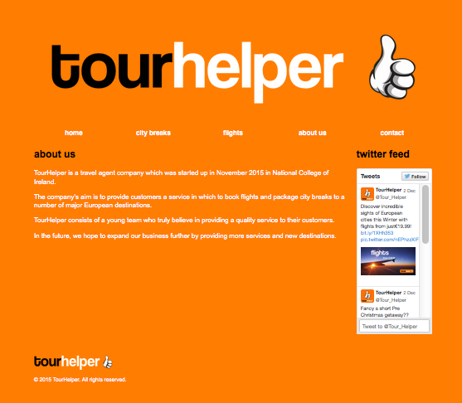

**contact.html**

The contact page is where users can make enquiries to the travel agent. On this page there is a form which the user must give their name, email and enquiry. When the user clicks the submit button, a confirmation box appears telling the user the enquiry has been sent.

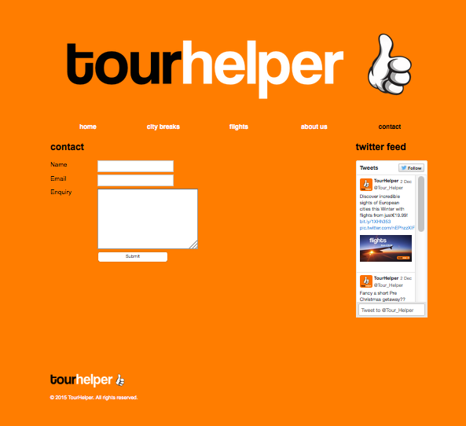

**layout.css**

The website itself only contains one CSS file. The CSS file holds the entire styling for the website. The CSS also holds the code which the website responsive. The way used to make the website responsive was done by the user media queries. When the website is viewed at width less than 480px the sidebar disappears altogether.

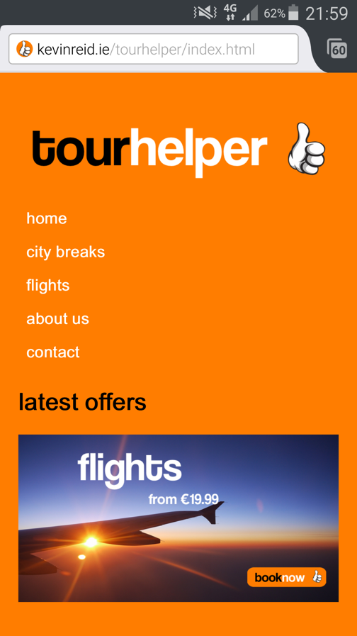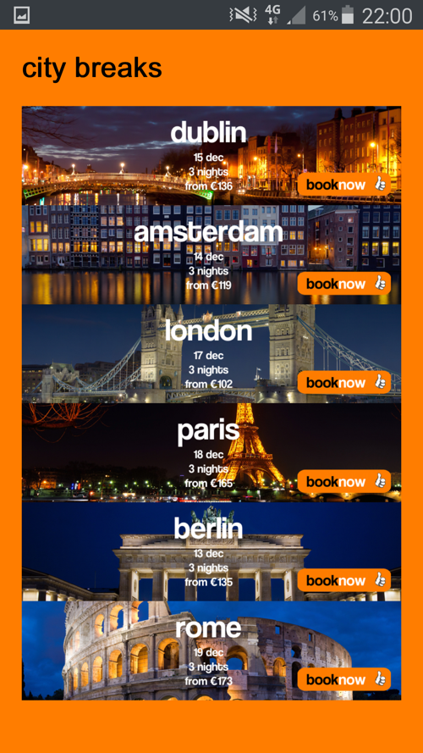

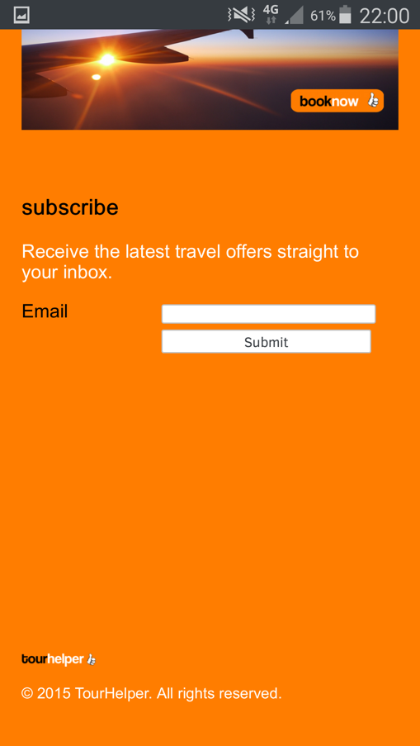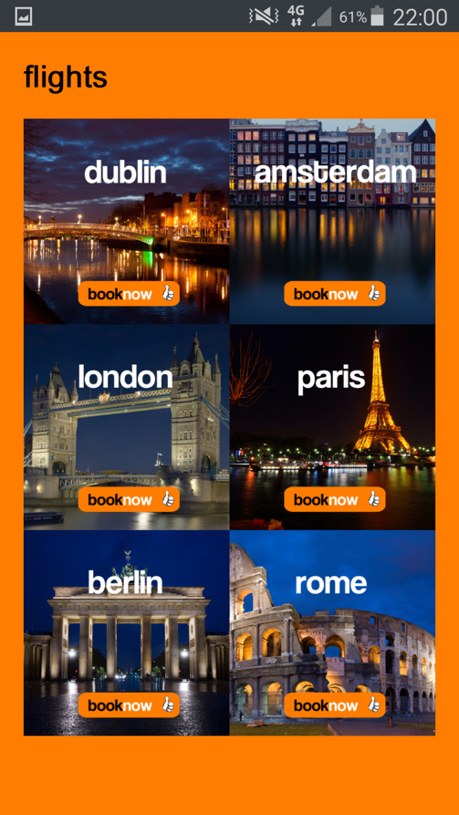

The method used to deployed the website online was through the use of my own personal web server. The website itself is hosted on my own website, kevinreid.ie. The program used to upload the website was a program called Cyberduck. Cyberduck is free and easy service to upload and manage websites.

**Validation**

Throughout the website, the validator noticed a number of errors which were present in every webpage. One common error in particular was naming of the unordered list tag for the navigation bar. The id tag for both the div for the nav bar and the ul tag shared the same id. So for every webpage I had to change to the ul id to navul and add this change into the CSS.

Another common error that featured in the website was for the input boxes on the forms. I had been using the name attribute to label each input box. The validator preferred I use the id attribute instead.

**index.html**

The index file features only one error. This error did not feature on the website until it went live. Once the website went live I noticed that the cycling banner did not appear. I luckily had a older version of the index file which had the working banner and came to the conclusion that banner needs have a name attribute but by adding a id instead will make the banner disappear.

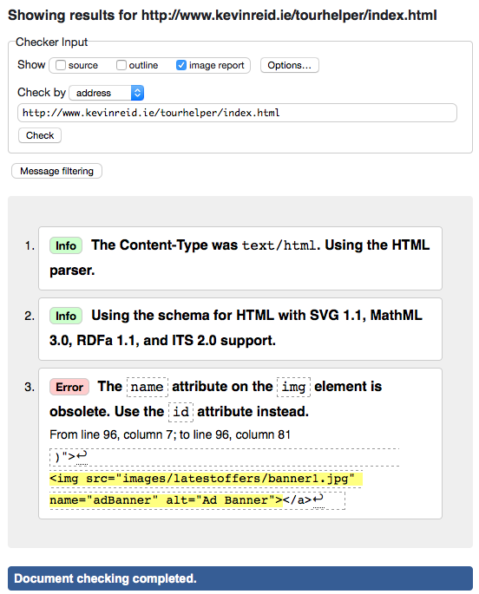

**city-breaks.html**

There were 1 or 2 errors for this page. For example, I had my <p> and <a> tags for the city breaks images in the wrong order.

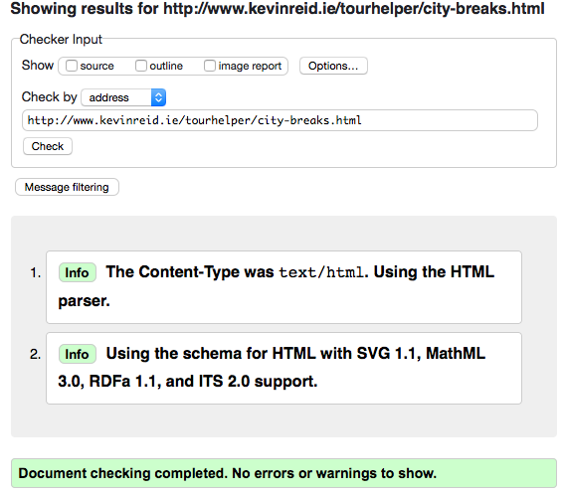

**flights.html**

There were 1 or 2 errors for this page. For example, I had my <p> and <a> tags for the city breaks images in the wrong order.

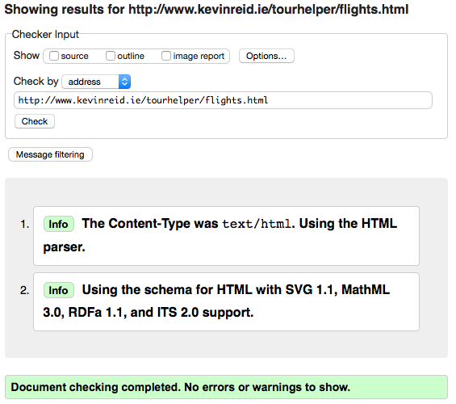

**dublin.html, amsterdam.html, london.html, paris.html, berlin.html, rome.html**

The errors found on the dublin.html page could found in the rest of the city booking pages.

These pages originally threw up a ton of errors. Most were easy to fix but others couldn’t be. An error which came up a lot was for attributes for the labels and input boxes. The validator wanted to change the name attributes to id attributes. This was no problem. I was left with 8 errors for each of these pages. These errors are for change the name attributes for the radio buttons. If try change each radio button something else it put radio button out of line on the webpage. I was unable to come up with a solution to fix these errors.

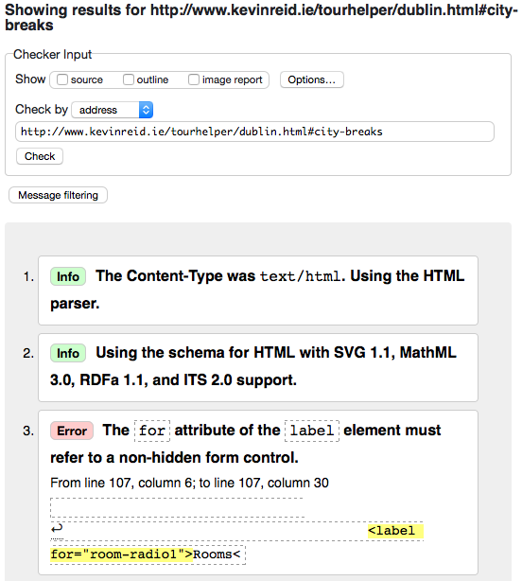

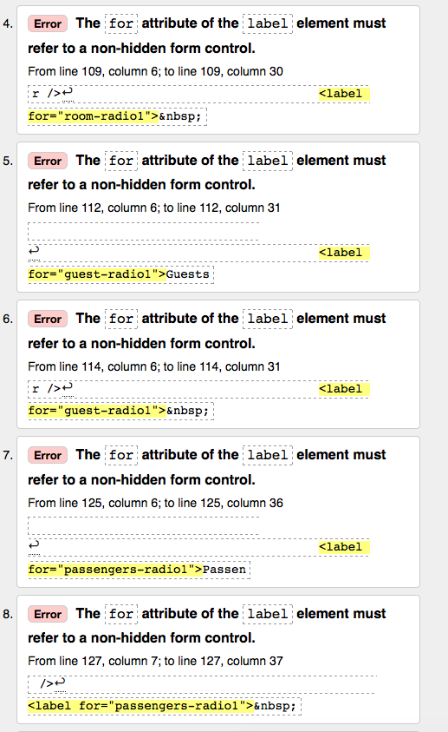

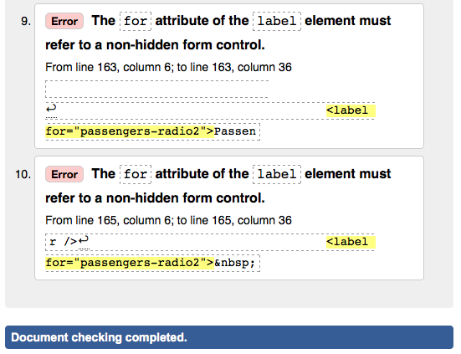

**about.html**

No errors ever appeared for the about page because for starters there isn’t very much to go wrong in page that just contains text.

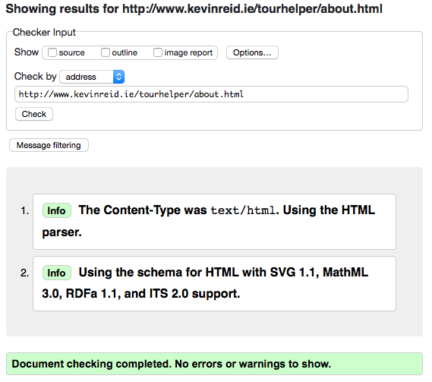

**contact.html**

On the contact page, again it showed errors for the labels and input boxes but these were easily fixed as I only had to change the name attributes to id attributes.

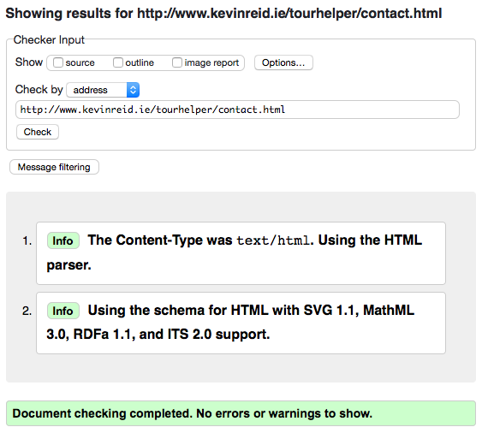

1. **Project Team**

Since I undertook this project by myself, I did everything that is to do with the website I on my own. At times I thought I should have done this project with some else because it is a lot of work for an individual to do on their own. But I don’t think I would have put that much effort into doing the project if I didn’t do it on my own.

1. **Conclusion**

Looking back at what I have achieved, I am very happy with outcome of this project. It exceeded my expectations completely and I am proud to showcase my work to my lecturers and peers.

I was originally sceptic on the whole theme of the project, but once I came up with the initial ideas for the website I set out to make sure I put in my full effort to complete it.

Of course, if I had more time to do this assignment I would include a vast number of other features to website. I would go back and try to implement some features that I tried to included in the website originally. I would’ve really liked to make the images for the city destinations responsive the way I had in mind. A few other changes I would’ve liked to make would include adding a Facebook like button as I thought this would be a nice feature.

Overall, I’m quite happy with the progress I made with the website. I hope that the client would be satisfied with work that was carried out for this project.

1. **References**

Thumbs Up. 2015. *Thumbs Up*. [ONLINE] Available at: <http://www.vectorfree.com/thumbs-up>. [Accessed 03 December 2015].

Coolvetica Font | dafont.com. 2015. *Coolvetica Font | dafont.com*. [ONLINE] Available at: <http://www.dafont.com/coolvetica.font>. [Accessed 03 December 2015].

Script 3.9. 2015. Script 3.9. [ONLINE] Available at: <http://www.javascriptworld.com/js4e/scripts/script03.09.html>. [Accessed 03 December 2015].

File:Tower Bridge London Feb 2006.jpg - Wikipedia, the free encyclopedia. 2015. *File:Tower Bridge London Feb 2006.jpg - Wikipedia, the free encyclopedia*. [ONLINE] Available at: <https://en.wikipedia.org/wiki/File:Tower_Bridge_London_Feb_2006.jpg>. [Accessed 03 December 2015].

File:Colosseum in Rome, Italy - April 2007.jpg - Wikipedia, the free encyclopedia. 2015. File:Colosseum in Rome, Italy - April 2007.jpg - Wikipedia, the free encyclopedia. [ONLINE] Available at: <https://en.wikipedia.org/wiki/File:Colosseum_in_Rome,_Italy_-_April_2007.jpg>. [Accessed 03 December 2015].

File:Berlin- Brandenburg gate (Brandenburg Tor) at night - 3942.jpg - Wikimedia Commons. 2015. File:Berlin- Brandenburg gate (Brandenburg Tor) at night - 3942.jpg - Wikimedia Commons. [ONLINE] Available at: <https://commons.wikimedia.org/wiki/File:Berlin-_Brandenburg_gate_%28Brandenburg_Tor%29_at_night_-_3942.jpg>. [Accessed 03 December 2015].

Dublin at Night (Ha'penny Bridge) | Flickr - Photo Sharing!. 2015. Dublin at Night (Ha'penny Bridge) | Flickr - Photo Sharing!. [ONLINE] Available at: <https://www.flickr.com/photos/lendog64/5574663324>. [Accessed 03 December 2015].

Amsterdam by Night | Flickr - Photo Sharing!. 2015. Amsterdam by Night | Flickr - Photo Sharing!. [ONLINE] Available at: <https://www.flickr.com/photos/lennartt/8384894154>. [Accessed 03 December 2015].

Paris night | Flickr - Photo Sharing!. 2015. Paris night | Flickr - Photo Sharing!. [ONLINE] Available at: <https://www.flickr.com/photos/jvieras/8586789587>. [Accessed 03 December 2015].

File:On the plane to Lisbon (5580623458).jpg - Wikimedia Commons. 2015. File:On the plane to Lisbon (5580623458).jpg - Wikimedia Commons. [ONLINE] Available at: <https://commons.wikimedia.org/wiki/File:On_the_plane_to_Lisbon_%285580623458%29.jpg>. [Accessed 03 December 2015].

File:Paris by night.jpg - Wikimedia Commons. 2015. File:Paris by night.jpg - Wikimedia Commons. [ONLINE] Available at: <https://commons.wikimedia.org/wiki/File:Paris_by_night.jpg>. [Accessed 03 December 2015].